**Programming the Arduino**

Step 1: Download the Arduino IDE from <https://www.arduino.cc/en/Main/Software> .

Step 2: Connect the Arduino and the PC with the USB cable that comes with the  
Arduino.

Step 3: Go to Device Manager, see ports [Windows 10] or Other Devices [ Other versions of Windows] and check whether the Arduino device is detected and the  
drivers are installed. Also identify the COM Port to which your Arduino is connected.

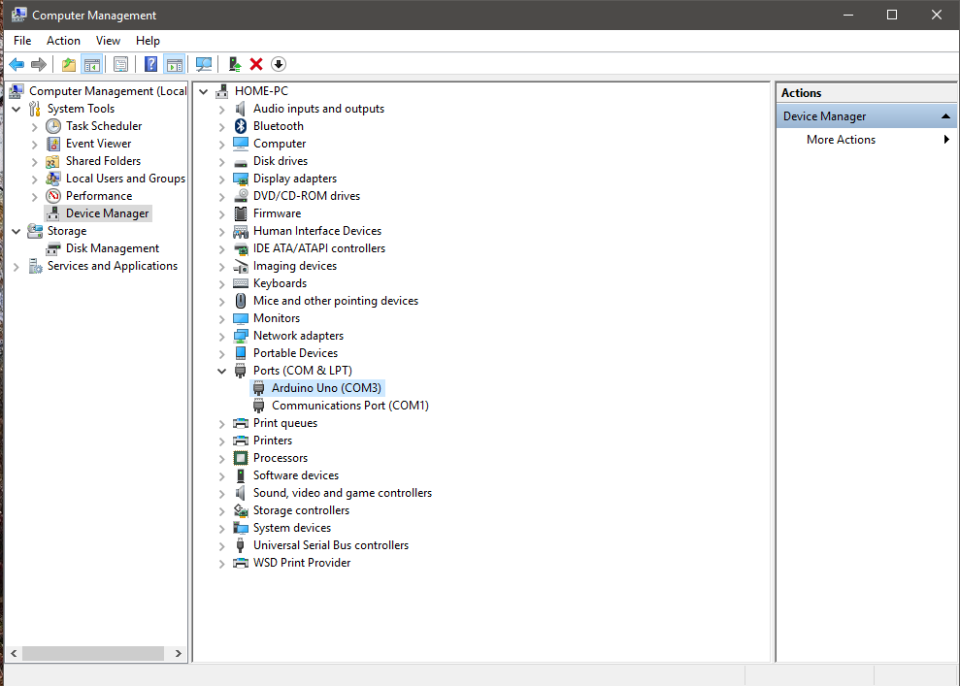

Step 4: Open the Arduino IDE and go to Tools -> Port and select the COM port to which your arduino is connected with the PC.

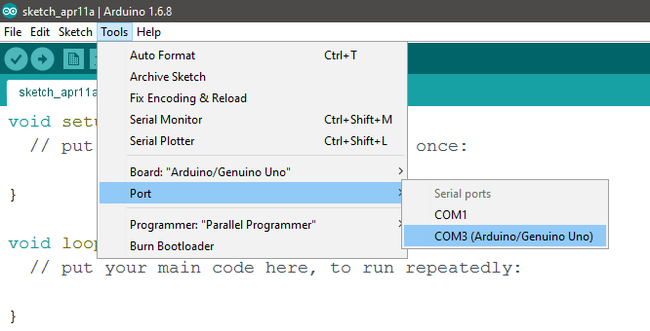

Step 5: Go to Tools -> Board -> and select the board that you have connected with the PC. In this case it is “Arduino / Genuino Uno“.

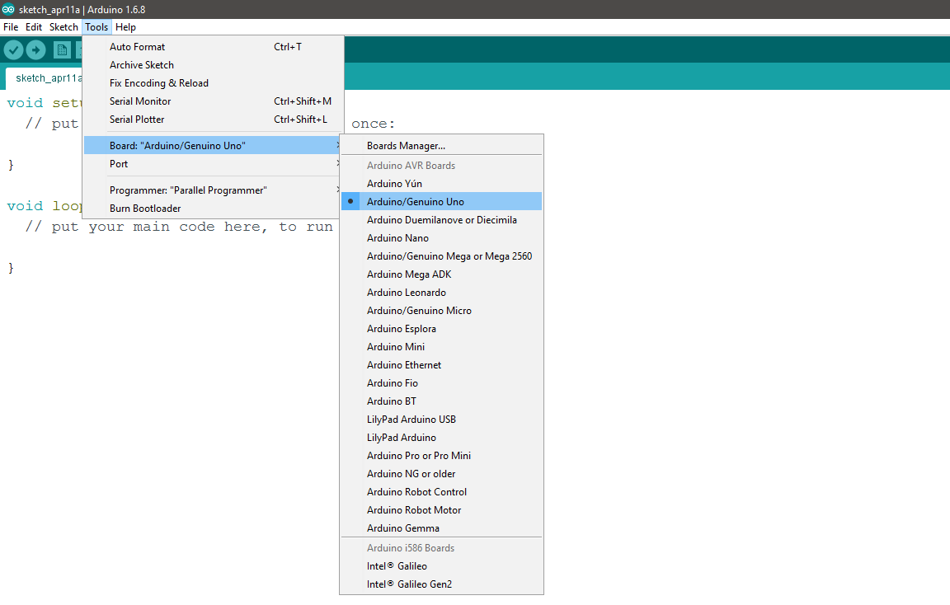

Step 6: Write your code into the editor of the IDE

Step 7: Click on the tick mark on the top left corner of the IDE to verify that your code has no compilation errors.

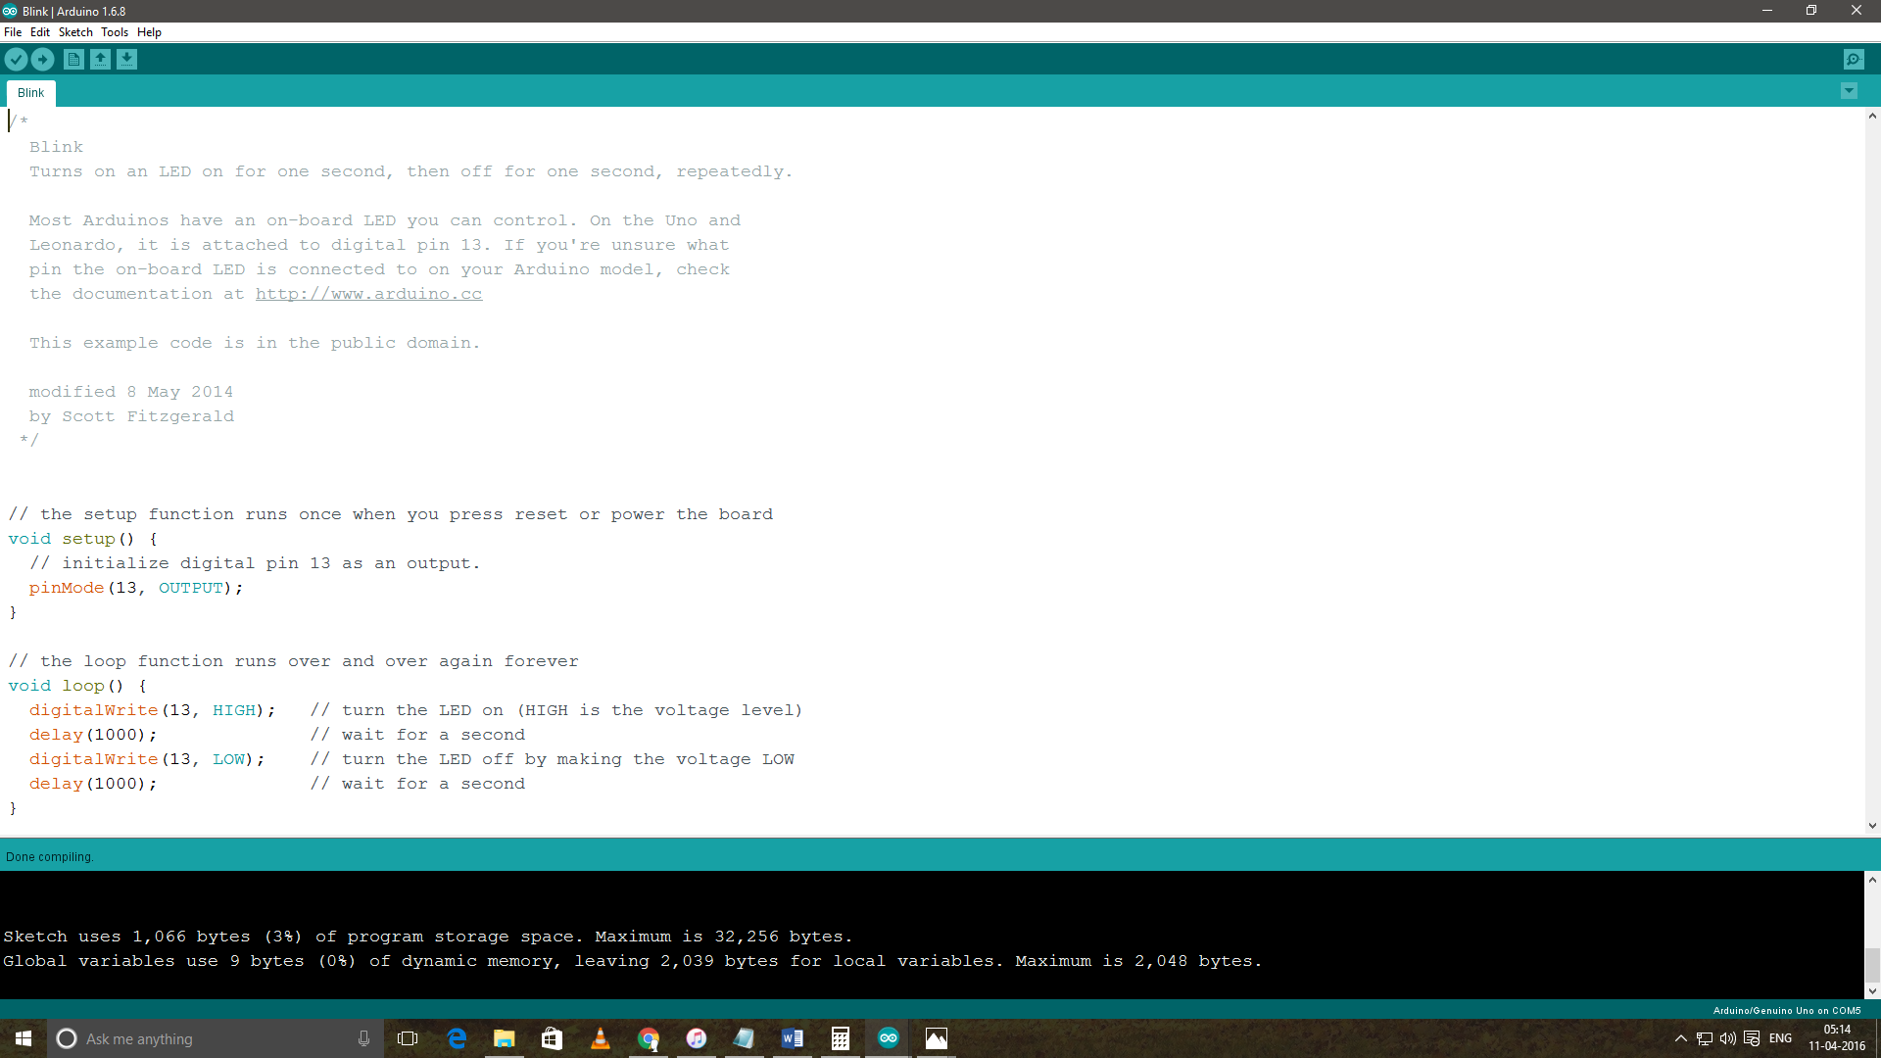

Step 8: Click on the arrow mark next to the tick mark to upload your code into the board. Look for the progress bar on the bottom right corner of the IDE and look for the “Done Uploading” message at the bottom left. Once this message comes, your code is safely uploaded into the Arduino board.

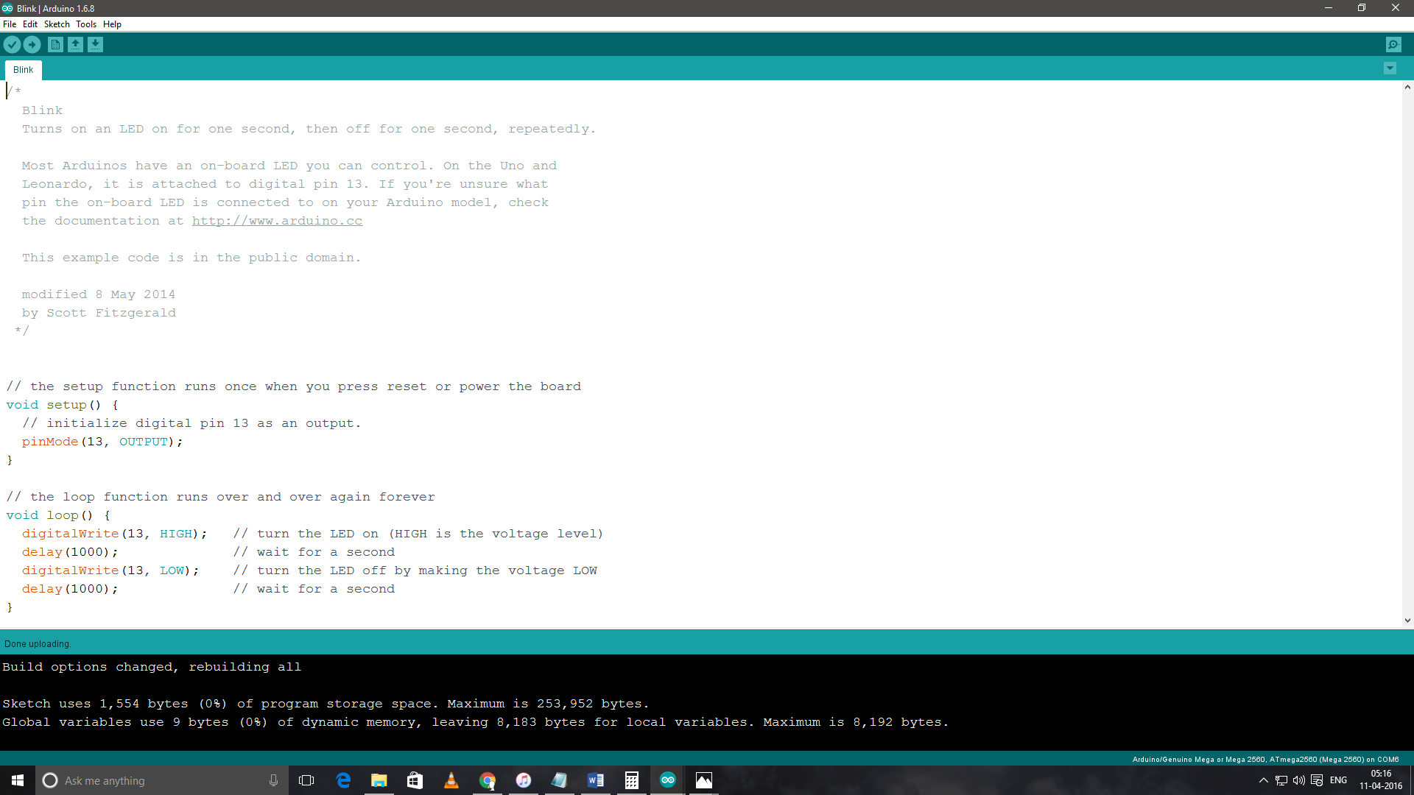

Step 9: In case, your sketch uses a Serial Monitor for displaying the output , click on the magnifying glass on the right top corner of the IDE to open the serial monitor. Select the baud rate that you have set to in the sketch.

